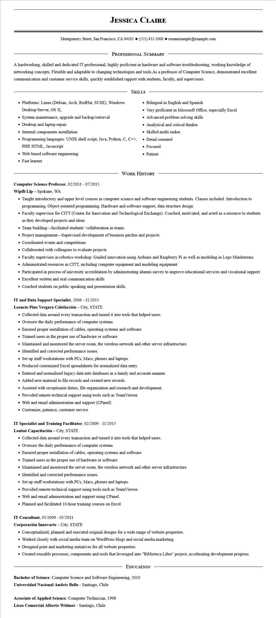
JESSICA CLAIRE
Montgomery Street, San Francisco, CA 94105 ♦ (555) 432-1000 resumesample@example.com
PROFESSIONAL SUMMARY
A hardworking, skilled and dedicated IT professional, highly proficient in hardware and software troubleshooting, working knowledge of networking concepts. Flexible and adaptable to changing technologies and tools. As a professor of Computer Science, demonstrated excellent communication and customer service skills, quickly established rapport with students, faculty, and supervisors.
SKILLS
• Platforms: Linux (Debian, Arch, RedHat, SUSE), Windows Desktop/Server, OS X,
• System maintenance, upgrade and backup/retrieval
• Desktop and laptop repair
• Internal components installation
• Programming languages: UNIX shell script, Java, Python, C, C++,
PHP, HTML, Javascript
• Web-based software engineering
• Fast learner
• Bilingual in English and Spanish
Very proficient in Microsoft Office, especially Excel
• Advanced problem solving skills
• Analytical and critical thinker
• Skilled multi-tasker
• Detail-oriented
• Focused
• Patient
WORK HISTORY
Computer Science Professor, 02/2011- 07/2015
Wipfli Llp - Spokane, WA
• Taught introductory and upper level courses in computer science and software engineering students. Classes included: Introduction to programming, Object-oriented programming, Hardware and software support, data structure design
• Faculty supervisor for CITT (Center for Innovation and Technological Exchange): Coached, motivated, and acted as a resource to students as they developed projects and ideas
• Team building-facilitated students' collaboration in teams
• Project management-Supervised development of business pitches and projects
• Coordinated events and competitions
• Collaborated with colleagues to evaluate projects
• Faculty supervisor in robotics workshop: Guided innovation using Arduino and Raspberry Pi as well as modeling in Lego Mindstorms
• Administrated resources in CITT, including computer equipment and modeling equipment
• Participated in process of university accreditation by administrating alumni survey to improve educational services and vocational support
• Excellent written and oral communication skills
• Coached students on public speaking and presentation skills.
IT and Data Support Specialist, 2006 - 11/2015
Leoncio Pino Vergara Calefacción - City, STATE
• Collected data around every transaction and turned it into tools that helped users.
• Oversaw the daily performance of computer systems.
• Ensured proper installation of cables, operating systems and software.
• Trained users in the proper use of hardware or software.
• Maintained and monitored the server room, the wireless network and other server infrastructure.
• Identified and corrected performance issues.
• Set up staff workstations with PCs, Macs, phones and laptops.
• Produced customized Excel spreadsheets for normalized data entry.
• Entered and normalized legacy data into databases in a timely and accurate manner.
• Added new material to file records and created new records.
• Assisted with receptionist duties, file organization and research and development.
• Provided remote technical support using tools such as TeamViewer.
• Web and email administration and support (CPanel)
• Customize, patience, customer service
IT Specialist and Training Facilitator, 02/2009 - 11/2015
Lontué Capacitación City, STATE
• Collected data around every transaction and turned it into tools that helped users.
• Oversaw the daily performance of computer systems.
• Ensured proper installation of cables, operating systems and software.
• Trained users in the proper use of hardware or software.
• Maintained and monitored the server room, the wireless network and other server infrastructure.
• Identified and corrected performance issues.
• Set up staff workstations with PCs, Macs, phones and laptops.
• Provided remote technical support using tools such as TeamViewer.
• Web and email administration and support using CPanel.
• Planned and facilitated 10-hour training courses on Excel
IT Consultant, 05/2009 - 05/2011
Corporación Innovarte - City, STATE
• Conceptualized, planned and executed original designs for a wide range of website properties.
• Worked closely with social media team on WordPress blogs and social media marketing.
• Designed print and marketing initiatives for all website properties.
• Created reusable processes, components and tools that leveraged into "Biblioteca Libre" project, accelerating development progress.
EDUCATION
Bachelor of Science: Computer Science and Software Engineering, 2010
Universidad Nacional Andrés Bello - Santiago, Chile
Associate of Applied Science: Computer Technician, 1998
Liceo Comercial Alberto Widmer - Santiago, Chile

